Bonnie
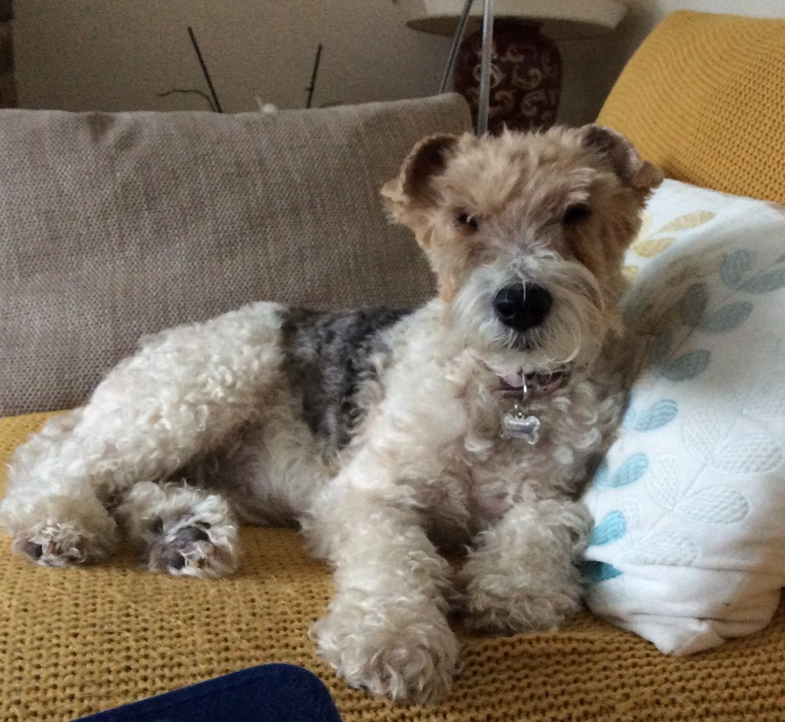
We rehomed Bonnie (originally named Jennie) in 2008 aged 2 years and we were her 3rd home. She was challenging in the beginning but with a lot of patience and training she was a lovely fantastic little girl.

Bonnie was a true foxy terrier, always in charge and very bossy! She loved to roll in anything that was truly smelly especially after a bath! She loved to run on Bigbury beach and paddle in the rock pools, go for long walks but her favourite and preferable thing was lunch afterwards at a café or pub. She loved having lots of cuddles and squeaking her toys and we were constantly stopped by folk to say how beautiful and good she was.

Bonnie battled with her health constantly, there were many times when we thought we might lose her but she always pulled through, she was a very tough little girl. Sadly, she had a massive stroke in May, 2 months short of being 12 years old, it was very sudden and a great shock and we are just devastated. Bonnie has left a huge hole in our lives and we miss her terribly every day.

Our fantastic special little girl, that we got from Lee, very much loved and missed, Sonya & Jenny proud mums of Bonnie. We were extremely lucky to have had her.

