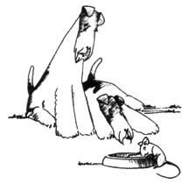
Fox Terrier Rescue
24th Annual Fun Day
Sunday 22nd July 2018
We would like to invite you to join us for this year’s Fox Terrier Fun Day, held once again at Standon Green End Farm by kind permission of Joyce and Tony Spackman. Last year saw our 23rd anniversary and we are thrilled to announce that £1000 was raised for the rescue.

We will be running all of our usual classes including fun and games, slowest sausage scoffer and not forgetting your fancy dress outfits and the raffle!

Please Note: This year we will not be able to provide a BBQ , however light refreshments ( tea & coffee) will be available as usual……DON’T FORGET TO BRING YOUR PICNIC.

In order to help make registration on the day easier we have simplified our entry process. Registration and entry of the first dog has been combined into a single upfront fee of £10 with additional dogs at £3 each. Don’t forget, all entries should also bring a donation of a raffle prize. Further entry payment on the day will no longer be required although you will still need to collect your number and programme before you can join in!

For those travelling from further afield there is the option of bringing your tent/caravan to spend Saturday night at the farm (a small charge will apply). Please contact Joyce Spackman directly (01920 438232) to make arrangements. Please note this number is ONLY for camping enquires.

If you would like to come and join the fun, please send your payment together with the slip at the bottom of the page before 15th July. Registration opens at 10 am at Standon Green End Farm (SG11 1BW).

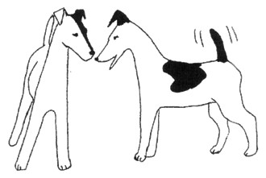
We look forward to seeing you on the 22nd July!

Yours sincerely,

Lena Smith
Please telephone 01362 687118 for all enquiries.

Don’t forget your raffle prize , chairs and Picnic

NAME:………………………………………………………………… ADDRESS:……………………………………………………………. ………………………………………………………………………………………………………………………… Tel. No:.………………………………… Email:………………………………………………………………….
Please tick if you would like to receive next years invite by email

Would you like to volunteer? Y or N
Entry fee (one dog only, including £5 non-refundable deposit) | £ 10.00
Additional dogs (£3.00 each) | £
Donation (Optional) | £
Total Amount Enclosed | £

Please enclose your entry fee (cheques made payable to Fox Terrier Rescue) and send to Mrs. Lena Smith, Long View, Dickfools Lane, Wendling, Dereham, Norfolk, NR19 2NF.

