Little old Lady Jessie came to me via Lee England at Fox Terrier Rescue.
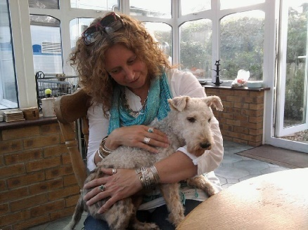
She was about 5 years old and had been with numerous homes before being surrendered to FTR. She had never been to the groomer and her coat was in a terrible state; she had torn out a lot of her fur. She had not been walked on a lead, didn’t have any recall and was extremely excitable … a bit of a handful!
It took a while for her to settle in and I was grateful for the wise words and support from Lee.
Right from our first meeting, Jessie showed the potential to be a fabulous foxie but she clearly did not expect to stay with me for long and took a long time to settle and relax.
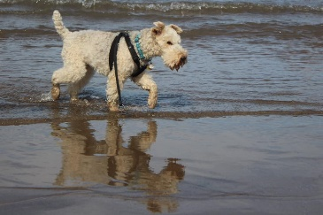
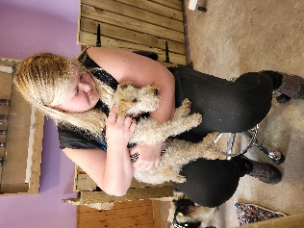
Lots of walks, strict boundaries and consistent expectations and the tender ministrations of a fabulous groomer over the next two years eventually convinced her that she had found her forever home. Jessie never grew her full wire coat back, but she still looked beautiful to me.
Jessie enjoyed our days out at the beach, walking in the Lakes and the Yorkshire Dales.

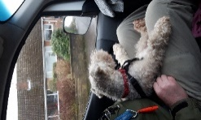
Jessie loved her life as a professional dog walker’s dog … her bossy personality kept the customers in line and if her legs could have reached the pedals, she probably would have driven the van!
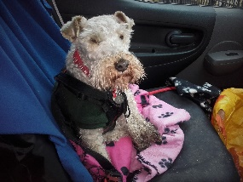

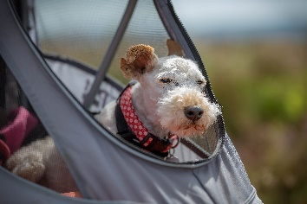
Her health gradually slowed her down and she eventually acquired a buggy so that she could continue to enjoy trips out.

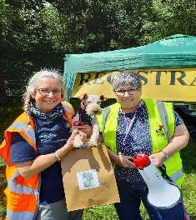

She achieved the accolade of ‘Oldest Dog’ at the 5th NFTM 2022.

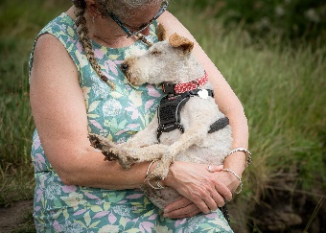
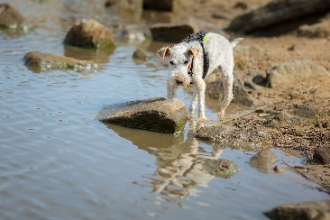
Sadly, that was Jessie’s final big trip out as she deteriorated rapidly in the following week. She spent her final morning out on the moor, where she loved to be, and went to sleep peacefully that evening, surrounded by love.
She was my unique, quirky sidekick and I will miss her terribly.
Thank you, Lee, for trusting in me and allowing me to have nearly 10 wonderful years with Lady Jessie.

